**Exercise 3: Numbers and Math**

1. Above each line, use the # to write a comment to yourself explaining what the line does.

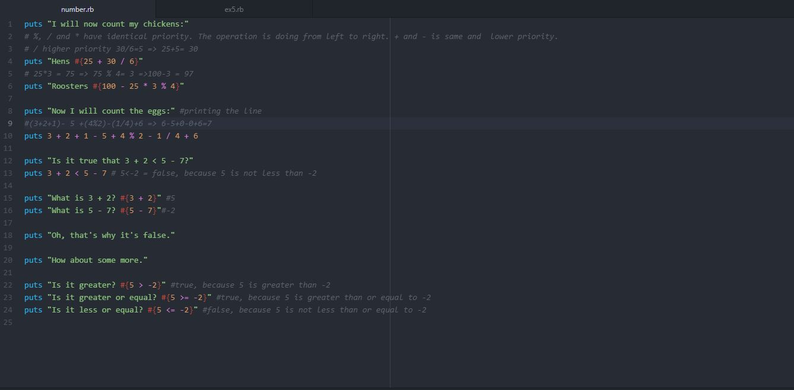

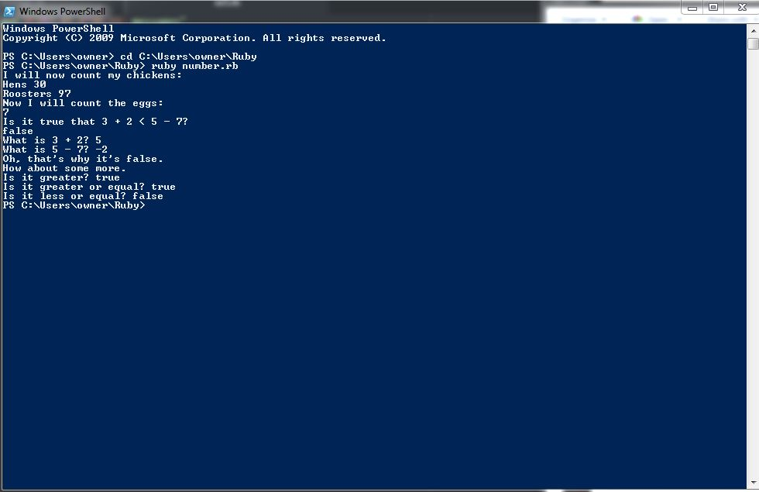

1. Remember in Exercise 0 when you started irb? Start irb this way again and, using the math operators, use Ruby as a calculator.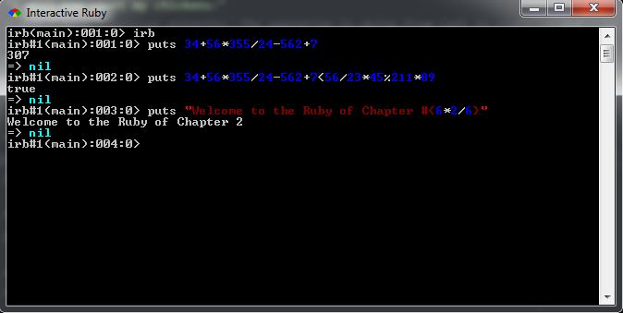
2. Find something you need to calculate and write a new .rb file that does it.

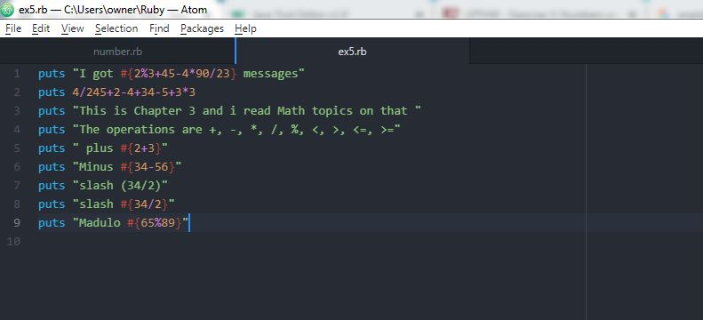

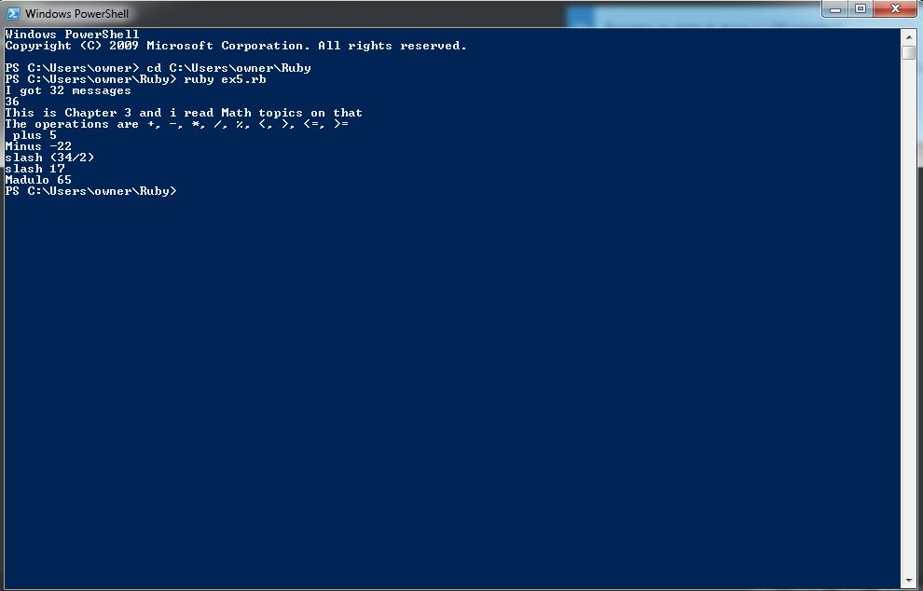

1. Rewrite ex3.rb to use floating point numbers so it's more accurate. 20.0 is floating point.

